**By Khaja Ali Ahmed 110425760**

|  |  |
| --- | --- |
| 3-D SpaceInvader |  |

**Game Description:**

The game I created is a 3-D version of space invaders. The game starts as soon as you double click to the executable file.

10 aliens are invading your planet! You must save the human race! You are equipped with the same weapons technology as the enemy alien. The Leader of Earth has placed trust in you to defeat this enemy. He has graciously given you his top secret fighter spaceship. Go now and save the world!

**Controls:**

**Move**: To move, the player can use the left and right keyboard keys.

**Shoot**: To shoot a bullet the player can use the up key.

**Perspective**: To change the y-axis perspective of the player, the user can click and drag his/her mouse.

**Menu**: To restart or quit the game at any time, the user can right click to access the main menu and select any of the 2 options.

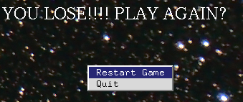

**Goal:**

The goal of our game is for the hero to destroy all the invading aliens before they come too close to the 3 green barriers protecting the hero. When the hero destroys all the aliens, the user is greeted with a congratulatory message.

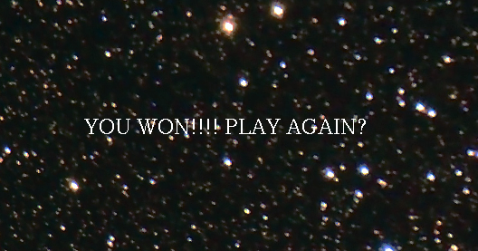

**Game Over:**

If the hero is unable to destroy all the aliens in time or if the alien bullet hits the hero, the user is greeted with a message telling the user they lost and encourages the user to try again.

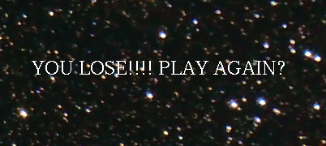

**Game Dynamics:**

10 aliens are moving in unison marching towards the hero. They move left to right. Each time they hit the right edge or left edge, they move down closer to the hero.

The hero can change perspective by clicking and dragging mouse.

The aliens will randomly shoot bullets down at the hero in an attempt to destroy the hero.

If the hero shoots a bullet up at the alien, both bullets will destroy each other and cancel each other out.

If the hero’s bullet or alien’s bullet hit the 3 green barriers, the bullets shot at the barrier are destroyed.

If the alien bullet hits the hero, the game is over.

If the hero’s bullet hits the alien the alien and the bullet is destroyed and the score is updated.

The hero will not be able to move off the screen. When left or right key pressed continuously, hero will move more smoothly across the screen.

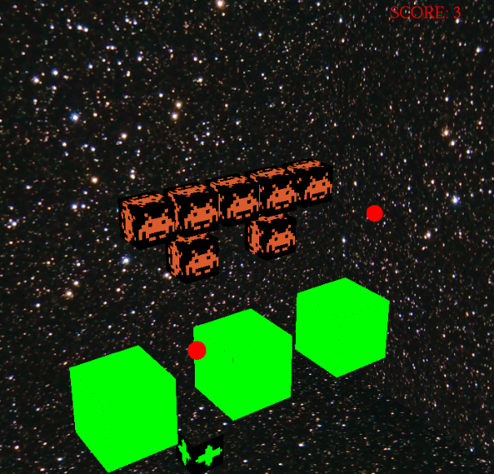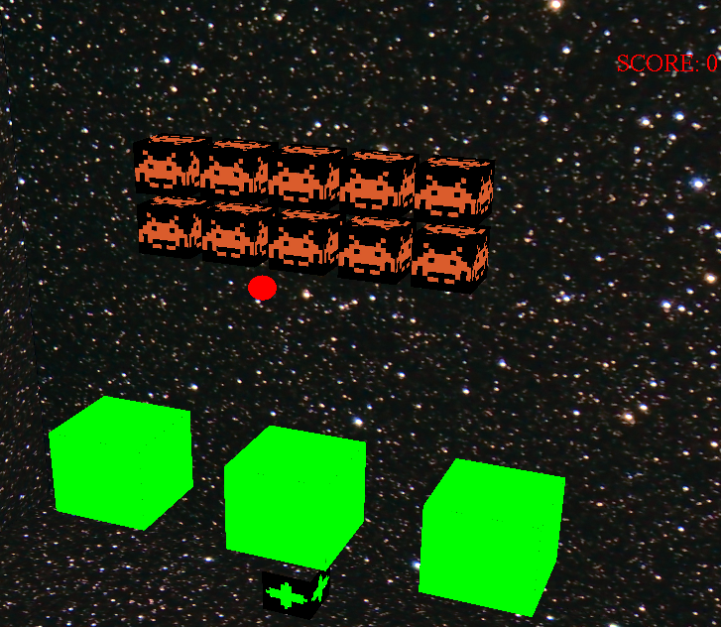

**OpenGL features used:**

1. Background image of stars in the galaxy
2. Background Music
3. Keyboard controls
4. Printing the score and end of game message on the screen
5. Changing the mouse’s cursor image

**Algorithms used:**

1. Algorithm to change the bullet’s color every 2 seconds
2. Algorithm to control the alien’s movements across the screen
3. Collision algorithm for collisions between bullets, barriers, aliens and the hero.
4. Hero movement algorithm to control hero’s movement and set boundaries for hero.